**Name : Nayan Mandliya**

**Roll No. : 1911027**

**Batch : MERN 1**

**Experiment No. : 3**

**Title:** Implementation of MongoDB, Node.js and Express js.

**Problem statement:** Consider the basic concepts of Node js Express.js and mongoDB, which are useful in the creation of an application.Consider the Company as database and create collection as employee.So make use of Nodejs and mongodb to perform following CRUD operations

1) Connecting to the Database (show using code and create collection in same database).

2) Create a Document.(make use of Insert one and insert())

3) Retrieving all Documents.(Create your own document using code only)

4) Find documents with Query Filter and regular expression.(Use as per the document you have created)

5) Update the Document using different options available.

6) Delete the document and drop collection as well

ANS)

1) Connecting to the Database (show using code and create collection in same database).

Code:

var Mclient=require('mongodb').MongoClient;

var url='mongodb://localhost:27017/';

Mclient.connect(url,(err,db)=>{

    if(err)

    {

        console.log(err);

        throw err;

    }

    else

    {

        console.log("Connection Established!!")

        var dbase=db.db('Company');

        dbase.createCollection('Employee',(err,res)=>{

            if(err)

            {

                console.log(err);

            }

            else

            {

                console.log("Collection created!!!");

                console.log(dbase.databaseName);

            }

            db.close();

        })

    }

})

Output:

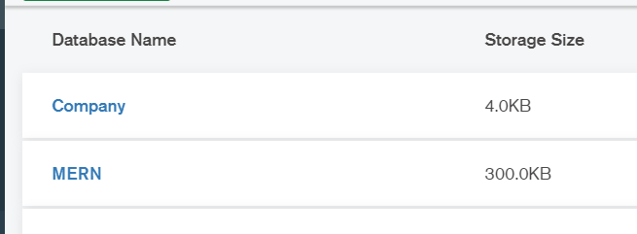

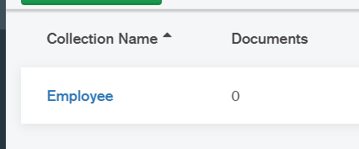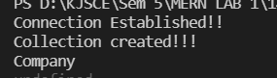

2) Create a Document.(make use of Insert one and insert())

Insert One:

Code:

var Mclient=require('mongodb').MongoClient;

var url='mongodb://localhost:27017/';

Mclient.connect(url,(err,db)=>{

    if(err)

    {

        console.log(err);

        throw err;

    }

    else

    {

        console.log("Connection Established!!")

        var obj={name: "Keish", age: "23", address:"Ghatkopar"};

        var dbase=db.db('Company');

        dbase.collection('Employee').insertOne(obj,(err,res)=>{

            if(err)

            {

                console.log(err);

            }

            else

            {

                console.log("Collection inserted using insertone!!!");

                db.close();

            }

        })

    }

})

Output:



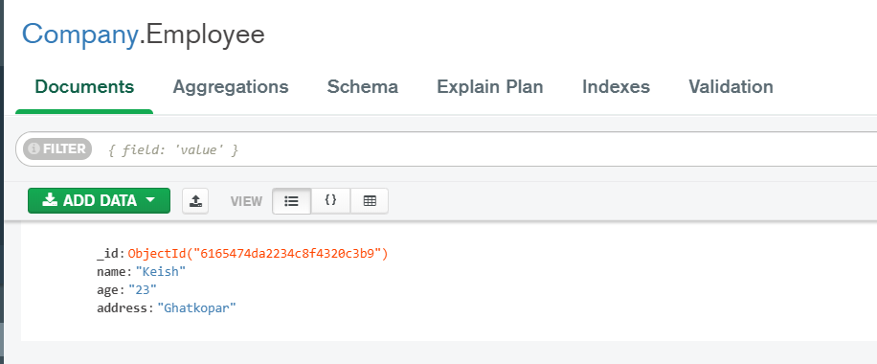

Insert:

Code:

var Mclient=require('mongodb').MongoClient;

var url='mongodb://localhost:27017/';

Mclient.connect(url,(err,db)=>{

    if(err)

    {

        console.log(err);

        throw err;

    }

    else

    {

        console.log("Connection Established!!")

        var obj=[{name: "Triven", age: "31", address:"Vidyavihar"},{name: "Robert", age: "18", address:"US"},{name: "Kannady", age: "21", address:"Paris"}];

        var dbase=db.db('Company');

        dbase.collection('Employee').insert(obj,(err,res)=>{

            if(err)

            {

                console.log(err);

            }

            else

            {

                console.log("Collection inserted using insert!!!");

                db.close();

            }

        })

    }

})

Output:



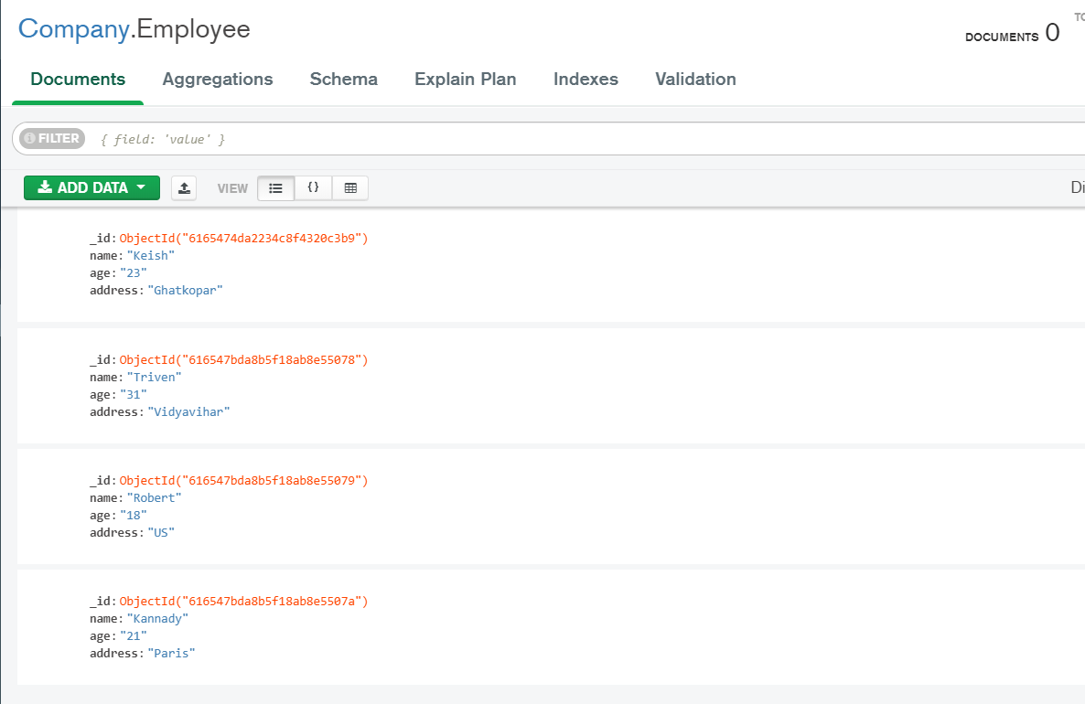

3) Retrieving all Documents.(Retrieve your own document using code only)

Code:

var MClient=require('mongodb').MongoClient;

var url="mongodb://localhost:27017/"

MClient.connect(url,(err,db)=>{

    if(err)

    {

        throw err;

    }

    else

    {

        console.log("Connection Established!!");

        var dbase=db.db('Company');

        dbase.collection('Employee').find({}).toArray((err,result)=>{

            if(err)

            {

                throw err;

            }

            else

            {

                console.log("The documents in the collection are : ");

                console.log(result);

                db.close();

            }

        })

    }

})

Output:

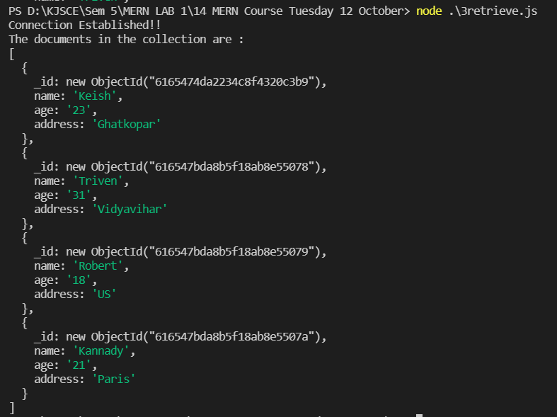

4) Find documents with Query Filter and regular expression.(Use as per the document you have created)

Code:

var MClient=require('mongodb').MongoClient;

var url="mongodb://localhost:27017/"

MClient.connect(url,(err,db)=>{

    if(err)

    {

        throw err;

    }

    else

    {

        console.log("Connection Established!!");

        var dbase=db.db('Company');

        var query={age: /^2/};

        dbase.collection('Employee').find(query).toArray((err,result)=>{

            if(err)

            {

                throw err;

            }

            else

            {

                console.log("The documents in the collection matching regex are  : ");

                console.log(result);

                db.close();

            }

        })

    }

})

Output:

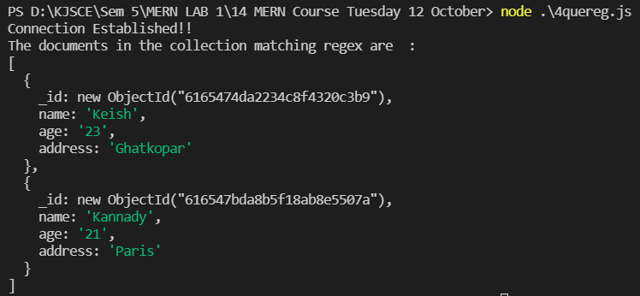

5) Update the Document using different options available.

UpdateOne:

Code:

var MClient=require('mongodb').MongoClient;

var url='mongodb://localhost:27017/';

MClient.connect(url,(err,db)=>{

    if(err)

    {

        console.log(err);

        throw err;

    }

    else

    {

        console.log("Connection Established!!")

        var dbase=db.db('Company');

        dbase.collection('Employee').updateOne({

            "name": "Keish"

        },

        {

            $set:

            {

                "name": "Krish"

            }

        });

        console.log("Document updated!!!")

        dbase.collection('Employee').find({}).toArray((err,result)=>{

            if(err)

            {

                throw err;

            }

            else

            {

                console.log("The documents in the collection are : ");

                console.log(result);

                db.close();

            }

        })

    }

})

Output:

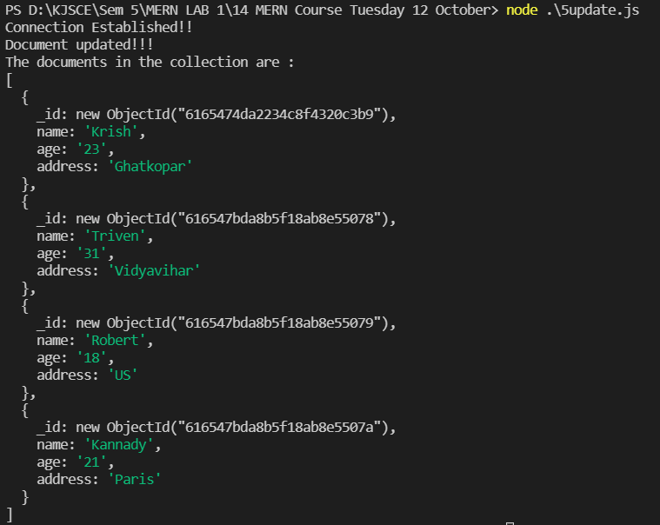

UpdateMany:

Code:

var MClient=require('mongodb').MongoClient;

var url='mongodb://localhost:27017/';

MClient.connect(url,(err,db)=>{

    if(err)

    {

        console.log(err);

        throw err;

    }

    else

    {

        console.log("Connection Established!!")

        var dbase=db.db('Company');

        dbase.collection('Employee').updateMany({

            age: /^2/

        },

        {

            $set:

            {

                "address": "Somaiya"

            }

        });

        console.log("Document updated!!!")

        dbase.collection('Employee').find({}).toArray((err,result)=>{

            if(err)

            {

                throw err;

            }

            else

            {

                console.log("The documents in the collection are : ");

                console.log(result);

                db.close();

            }

        })

    }

})

Output:

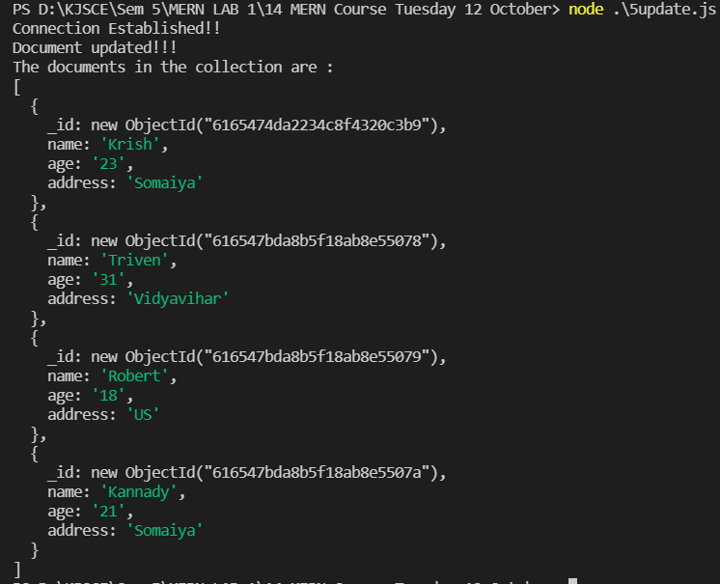

6) Delete the document and drop collection as well

Delete document:

Code:

var Mclient=require('mongodb').MongoClient;

var url='mongodb://localhost:27017/';

Mclient.connect(url,(err,db)=>{

    if(err)

    {

        console.log(err);

        throw err;

    }

    else

    {

        console.log("Connection Established!!");

        var query={name: "Krish"};

        var dbase=db.db('Company');

        dbase.collection('Employee').deleteOne(query,(err,result)=>{

            if(err)

            {

                console.log(err);

            }

            else

            {

                console.log("Document removed!!!");

            }

        })

        dbase.collection('Employee').find({}).toArray((err,result)=>{

            if(err)

            {

                throw err;

            }

            else

            {

                console.log("The documents in the collection are : ");

                console.log(result);

                db.close();

            }

        })

    }

})

Output:

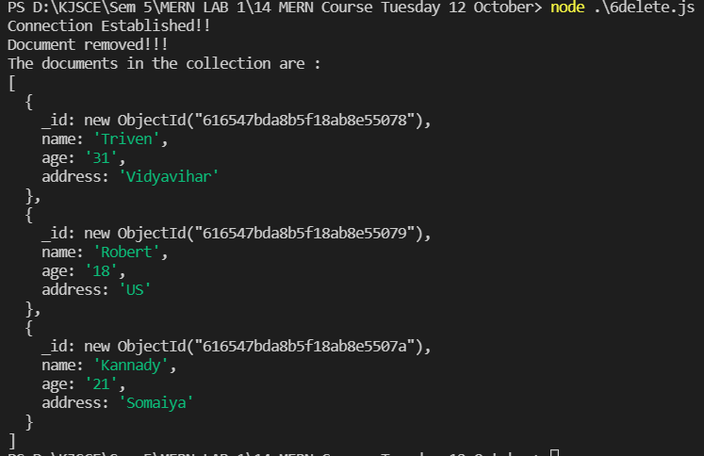

DeleteMany:

Code:

var Mclient=require('mongodb').MongoClient;

var url='mongodb://localhost:27017/';

Mclient.connect(url,(err,db)=>{

    if(err)

    {

        console.log(err);

        throw err;

    }

    else

    {

        console.log("Connection Established!!");

        var query={age: /^2/};

        var dbase=db.db('Company');

        dbase.collection('Employee').deleteMany(query,(err,result)=>{

            if(err)

            {

                console.log(err);

            }

            else

            {

                console.log("Document removed!!!");

            }

        })

        dbase.collection('Employee').find({}).toArray((err,result)=>{

            if(err)

            {

                throw err;

            }

            else

            {

                console.log("The documents in the collection are : ");

                console.log(result);

                db.close();

            }

        })

    }

})

Output:

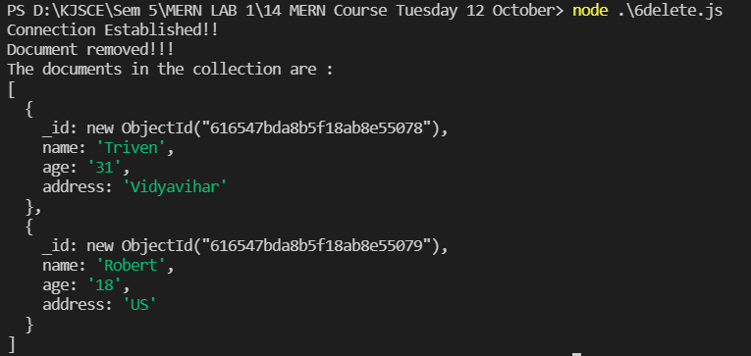

Drop collection:

Code:

var MClient=require('mongodb').MongoClient;

var url="mongodb://localhost:27017/"

MClient.connect(url,(err,db)=>{

    if(err)

    {

        throw err;

    }

    else

    {

        console.log("Connection Established!!");

        var dbase=db.db('Company');

        dbase.collection('Employee').drop((err,result)=>{

            if(err)

            {

                throw err;

            }

            else

            {

                console.log("Collection removed!!");

                db.close();

            }

        })

    }

})

Output:



